Sarcasm Detection Using Fine-Tuned BERT Models: A Comparative Study
1. Introduction
Detection of sarcasm is a complex issue in natural language processing because it depends on the contextual meaning, linguistic subtleties, and contradictions of meaning. In contrast to a simple sentiment analysis, sarcasm can frequently have the opposite meaning, and it can be important that the model is able to understand some nuances of the text and relationships in the context of the text (Joshi et al., 2017). The spread of sarcastic texts on the social media and the news headlines has led to an acute demand of automated detecting systems that have the ability to grasp such intricate linguistic patterns.
This paper is about the problem of detecting sarcasm with the News Headings Dataset (Misra and Grover, 2021), including 28,619 news entries (headlines) of The Onion (satirical) and HuffPost (legitimate news). The sample size is fairly balanced with 52.4 percent of non- sarcasmic (14,985), and 47.6 percent sarcastic (13,634) samples. Headlines are on average 9.8-10.3 words long with sarcastic headlines being slightly more variable (std: 3.85) than non-sarcastic ones (std: 2.89). The main aim is to establish and analyze a BERT-based classification system and compare its results with those of conventional machine learning baselines, namely, to determine whether contextual embeddings are of any substantial benefit in comparison with bag-of-words in this task.
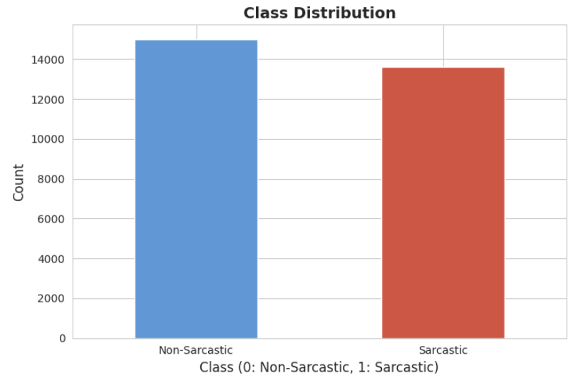
Figure 1:Class Distribution
2. Methodology
2.1 Data Preprocessing
The data displays clear linguistic features, and sarcastic headlines often introduce the words of such absurdist features as man, report, area, whereas the non-sarcastic ones include more political terms (trump, donald, says). This lexical differentiation is an indication that successful classification needs contextual awareness other than mere matching of keywords- a hypothesis that is confirmed by our comparative analysis.
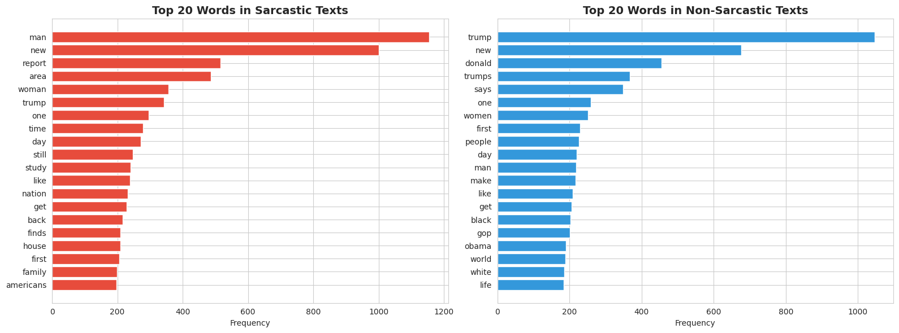
Figure 2: top 20 most common words in both classes
The dataset was preprocessed systematically to guarantee the quality of data and compatibility between the model. Upon loading the SarcasmNewsHeadline dataset on Hugging Face, we checked that no values were missing and carried out text cleaning operations such as converting to lower case, deleting URLs, and special characters. Stratified sampling in partitioning the data was used to maintain the balance of classes by splitting the data into training (64% n=18,316), validation (16% n=4,579) and test (20% n=5,724) sets. This stratification provides representative assessment and eliminates the bias of imbalance of classes when training the models.
2.2 Baseline Models
The two conventional machine learning models were used as baselines to use them as benchmarks of performance. Both models atomized TF-IDF (Term Frequency-Inverse Document Frequency) that use a vocabulary size of 5,000 features along with unigrams and bigrams ( ngram_range (1,2) ) but dropped English stop words.
L2 regularization with balanced class weights was used to counter possible imbalance in the Logistic Regression which was trained until 1,000 iterations. The Laplace smoothing (alpha=1.0) was used with Multinomial Naive Bayes in the assumption of conditional independence of features. These models are the classical bag-of-words model, as they are able to capture the frequency patterns of words, but understand them out of context.
2.3 BERT Model Architecture and Training
Pre-trained bert-base-uncased model was optimized (Devlin et al., 2019), the model has 109.5 million parameters and is trained on 12 transformer layers with 768 hidden dimensions. The analysis of token length indicated that the 95 th percentage of 22 tokens was obtained as the maximum sequence length of 32 tokens, which is a good balance between the cost of computing and information storage and 95 th percentile of headline lengths.
The BERT tokenizer used WordPiece tokenization which transformed the text to subword units that were separated by special tokens [CLS] to indicate the classification and separated by sequence tokens [SEP] to indicate sequence separation. The tokenization, padding, and attention mask generation was done through a custom PyTorch Dataset. It was a binary classification head to be placed on the top of BERT pooled [CLS] token representation.
Training Configuration:- Optimizer: AdamW with learning rate 2×10⁻⁵ and weight decay 0.01 ,Learning rate schedule: Linear warmup (10% of total steps) followed by linear decay ,Batch size: 16 ,Epochs:3
2.4 Evaluation Metrics
Accuracy, precision, recall, and F1-score, which is the harmonic mean of the first two, were used to measure model performance, especially when producing a balanced evaluation. The confusion matrices gave an in-depth understanding of the classification patterns, false positives (non-sarcastic incorrectly predicted as sarcastic) and false negatives (sarcastic incorrectly predicted as non-sarcastic).
3. Results and Discussion
3.1 Model Performance Comparison
BERT significantly outperformed both baseline models across all metrics on the test set, as shown in Table 1.
Table 1: Comparative Performance on Test Set
Model | Accuracy | Precision | Recall | F1-Score
Logistic Regression | 0.7820 | 0.7806 | 0.7543 | 0.7673
Naive Bayes | 0.7760 | 0.7804 | 0.7374 | 0.7583
BERT | 0.9263 | 0.9361 | 0.9072 | 0.9214
BERT had an accuracy of 92.63 with an F1-score of 0.9214, which is 20.09 percentage higher than the highest baseline (Logistic Regression). This significant improvement shows that BERT has a higher ability to capture contextual complexities that are needed to identify sarcasm. The accuracy of 93.61 per cent refers to the accuracy of BERT in positive prediction and the recall of 90.72 per cent represents the high sensitivity of BERT to sarcastic cases (Misra and Grover, 2021).
The analysis of the confusion matrix showed that BERT made correct predictions in 2,828 non-sarcastic and 2,474 sarcastic headlines with falsely detected headlines being 169 and false negative predictions being 253- an overall error rate of 7.37. The two baseline models reached an equal result (F1 ~ 0.76), which supported the claim that traditional bag-of-words methods do not cope with the contextuality of sarcasm.
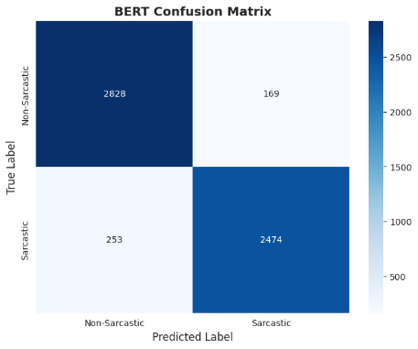
Figure 3:BERT Confusion Matrix
3.2 Training Dynamics
The training history revealed efficient learning with validation accuracy improving from 92.38% (epoch 1) to 93.60% (epoch 3), while F1-score increased from 0.9198 to 0.9322. The divergence between training loss (decreasing) and validation loss (slight increase) after epoch 2 suggests mild overfitting, though validation metrics continued improving, indicating effective regularization through weight decay and dropout in BERT's architecture.
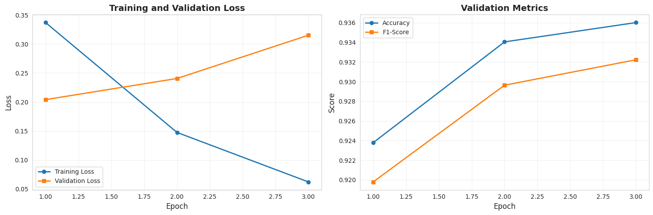
Figure 4: Training History
3.3 Error Analysis
Analysis of the 422 misclassified examples (7.37% of test set) revealed distinct patterns. Analysis of text length revealed that there was no significant difference between the correct and incorrect prediction of the headline length since the correct prediction used 10.11 words, and the incorrect prediction used 9.77 words. Instead, the elicitation of subtlety of sarcasm and the need to have knowledge outside oneself seem to be the cause of errors in classification (González-Ibáñez, et al., 2011).
3.4 Limitations and Discussion
Although its performance has been good, it has a number of limitations. To begin with, the method uses only text as a means, but sarcasm is usually supported by prosody, expressions, and body language cues in live communication, which cannot be found in the texts-only data. Second, sarcasm is very context-dependent in culture and time, often relying on contemporary phenomena, familiarity and implicit allusions that might not be well represented in the pretraining data of BERT. Third, the data is domain-specific (only news headlines), and thereby this aspect can limit the model to generalizing to other areas like social media or conversational text where sarcasm is not expressed in the same manner (Joshi, et al., 2017).
4. Conclusion and Future work
Overall, this paper proves that fine-tuning BERT models are much more effective than other traditional machine learning methods in detecting sarcasm in news headlines. The proposed method, with 92.63% accuracy and a F1-score of 0.9214, is about 20 percent better than the baseline models. These findings affirm that the profound contextual knowledge provided by the transformer architectures is indispensable in the recognition of sarcastic words because it tends to be based on the coded semantic contradiction and implicit meaning. The main insights that have been made out include the fact that the contextual embeddings of BERT are not only effective in capturing patterns related to sarcasm, but the traditional bag-of-words models are weak in addressing context-specific tasks. The analysis of errors also indicates that it is still challenging to detect subtle sarcasm and those instances that need a wider context to be able to determine.
Future work can be improved in robustness and generalization in a number of directions. A further development of the architecture, including RoBERTa or DeBERTa might provide more powerful context representations. Training can be diversified by using data augmentation strategies such as back-translation, paraphrasing, etc. Ensemble techniques can be used to enhance reliability through presence of complementary model strengths and domain adaptation to platforms such as Twitter or Reddit can be used to overcome stylistic variation. Metadata or multimodal clues can also add to contextual knowledge.
References
Devlin, J., Chang, M. W., Lee, K., & Toutanova, K. (2019). BERT: Pre-training of deep bidirectional transformers for language understanding. In Proceedings of the 2019 Conference of the North American Chapter of the Association for Computational Linguistics (pp. 4171-4186).
González-Ibáñez, R., Muresan, S., & Wacholder, N. (2011). Identifying sarcasm in Twitter: A closer look. In Proceedings of the 49th Annual Meeting of the Association for Computational Linguistics (pp. 581-586).
Joshi, A., Bhattacharyya, P., & Carman, M. J. (2017). Automatic sarcasm detection: A survey. ACM Computing Surveys, 50(5), 1-22.
Misra, R., & Grover, J. (2021). Sculpting Data for ML: The first act of Machine Learning. Available at: https://www.researchgate.net/publication/351287132

